Mission College Classified Senate Retreat
August 1, 2019
Los Altos Hills
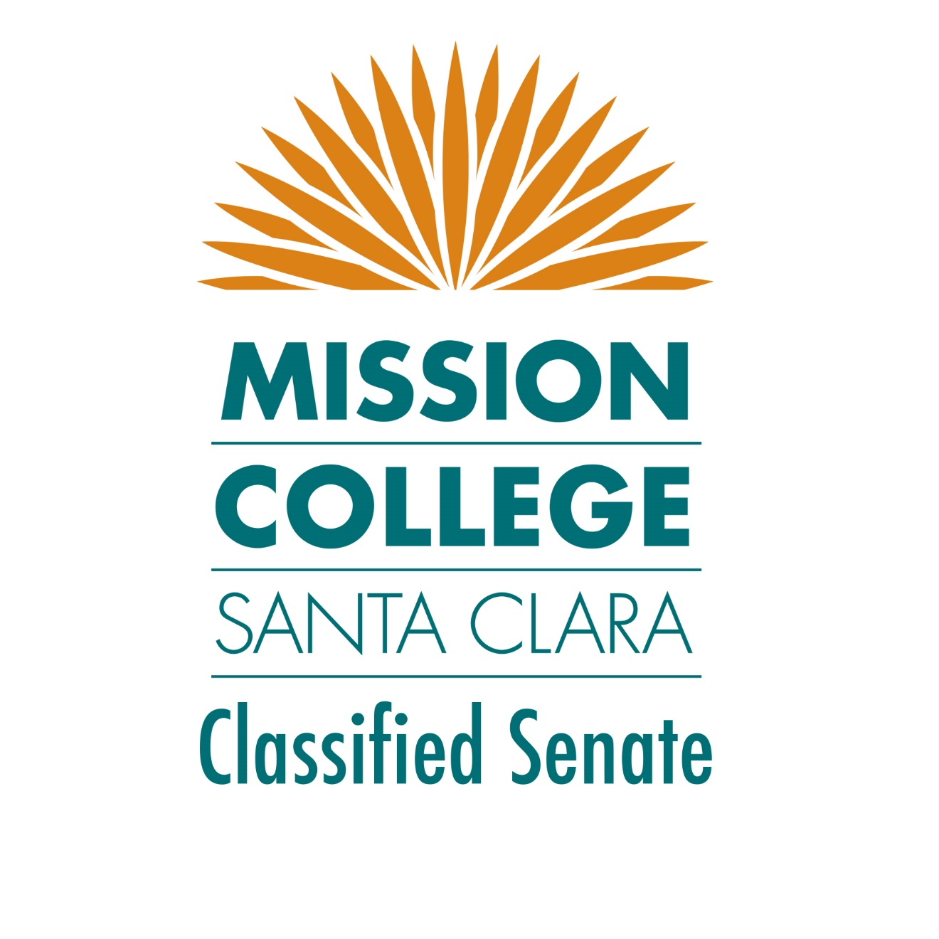

Contents
Mission College Classified Senate Retreat August 1, 2019 Los Altos Hills i
Retreat Planner / Facilitator: 1
Retreat Note taker: 1
Photographer: 1
Officers in attendance: 1
Senators in attendance: Kendall Harrison, 1
Members in attendance: 1
Community Agreements 1
Activities 1
Ice Breaker: M&Ms 1
Team Building Activity - Mid Day: “Back to Back” 1
Team Building Activity: End of Day Puzzle 1
Retreat Photo 2
Classified Senate Overview 3
By Laws 3
9+1 3
SWOT Analysis on 2018-2019 Goals 4
Goal Setting Activities: 2019-2020 Classified Senate Goals 5
Brainstorming: 5
Voting Results of Priorities: 6
Conclusion 7
Summary of Goals 7
Action: 7
Questions: 7
Additional suggestions: 8
Retreat Feedback: 8
Retreat Materials 8
Updates - Follow Up: 2019-2020 High-Level Planning Initiated 9
Strategic Planning Document 9
Classified Senate Mission Statement Drafts 9
Engagement: Area Representatives Senators [Confirmations Needed] 11

Retreat Planner / Facilitator: Kristal Dela Cruz, Classified Senate Secretary
Retreat Note taker: Thanh Do, Classified President
Photographer: Christopher Bibat, Classified Treasurer
Officers in attendance: Thanh Do, Dat Nguyen, Kristal Dela Cruz, Christopher Bibat
Senators in attendance: Kendall Harrison, Lusyna Narvaez, Mario Flores, Nini Reyes-Bollinger, Renee Ruzicka, Vianey Topete, Zita Melton
Members in attendance: Connor Keese, Danielle Ramirez-King, Lori Hampton, Lucia Moreno, Queenie Chan

Community Agreements
- 1 person, 1 mic
- Be engaged (Cell phone on silent)
- Respectful of time
- Be open to outcome, not attached to outcome
- No one knows, everything, together we know a lot
- Tell the truth without blame or judgement
- Pay attention to what has heart and meaning
- Show up and be present
- Willingness to ask questions, for clarification

Activities

Ice Breaker: M&Ms
Each person takes 2-5 M&Ms. Each color corresponds to a prompt. Each person answers the prompt depending on the M&M color. Opportunity for team members to share about themselves.

Team Building Activity - Mid Day: “Back to Back”
Group divided into three lines of four facing forward. The person in the front of the line is given a pencil and piece of paper. The last person is shown an image. The person then draws the image on the back of the person in front of them - this repeats until the person in the front receives the drawing on their back. The person now needs to draw on the piece of paper what they “felt” on their back.
Theme: Communication – effects of not clear communication, no verbal communication.
Team Building Activity: End of Day Puzzle
Each person takes a piece and write their name, word to describe Classified Senate for next year. Team works together to put the puzzle together. End result: Circle with logo and the word “one” symbolizes that each person is important piece to Senate.
Theme: Teamwork

Retreat Photo

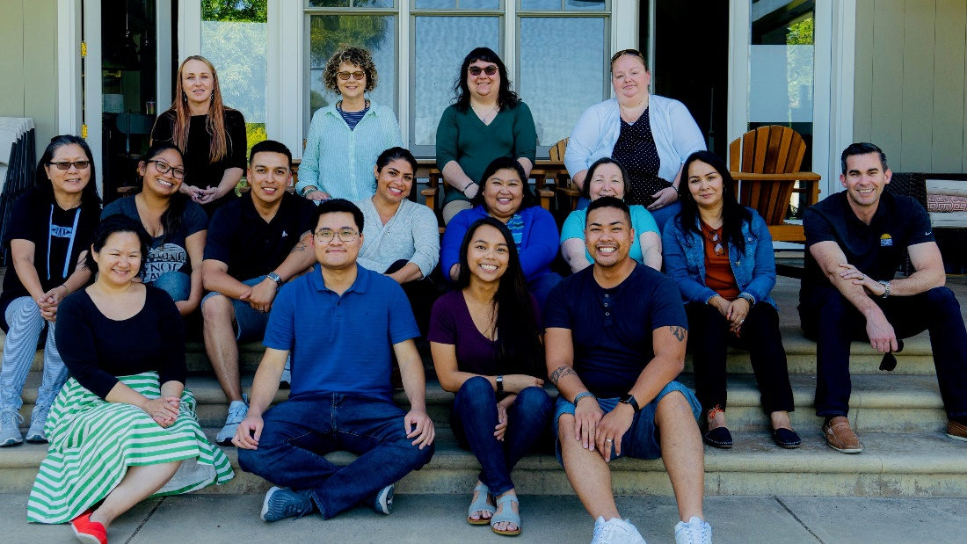
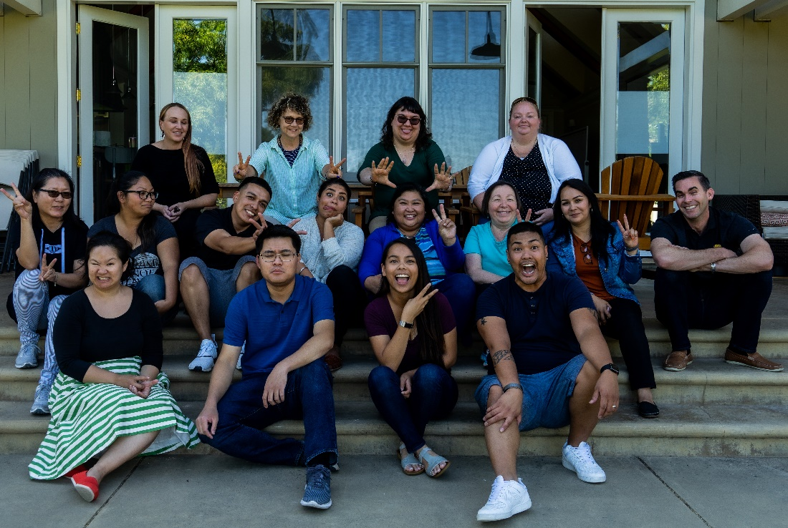

Classified Senate Overview
What is Classified Senate? Pull from Power Point.
The Classified Senate represents the needs, concerns, and viewpoints of the classified staff with respect to the District Participatory Governance System, excluding all matters related to collective bargaining and grievances. It is one of the constituent groups of Mission College's shared governance structure and it stands as a council whose members are elected by the MC classified staff.
Classified Senate Charge: Represent Classified Professionals in Participatory Governance process. (Zita)

By Laws
Input:
- Communications Officer might be a future change in By-Laws
- Elections in March, following in July 2020, Interests in Officer position
- Aligning our charge to 9+1? To Goals, Vision, Mission of Classified Professionals
- Update GAP to College Council
- Need feedback from missing senators

9+1
Notes:
- The college recognizes the Classified Professional voice, expertise and experience matter in regards to decision making at the college.
- Not all colleges have 9+1, even West Valley. We’re very lucky to have this in place. We need to build that participation.
Input:
- While Classified Senate doesn’t take on activities of the union, we are complementary to the union. While we are separate, we need to respect the boundaries. Reference to 2014 Agreement.
- Communication would be key in helping CEA.
- How do we activate 9+1? Course of action. Currently, 9+1 is not enforceable because it is not a Board and administrative policy.
- Once WV approves their 9+1, we could move forward with setting up a district Board and Administrative Policy.
- We are not systemic about decision making, how do we use technology to enforce this?
- Plan of next steps for Bumping Memo.
- West Valley 9+1 memo was rejected by the college.
- Engagement with WV Classified Professionals,
- Action: Research 9+1 policy process for faculty and students.

SWOT Analysis on 2018-2019 Goals
Strengths  - Improved communication  - Professional Development, leveraged opportunities from other groups  - On-Course was excellent. | Weakness  - Sustaining the practice of communication  - Encouragement and motivation from supervisors to support professionals in participatory governance  - Committee language participation different in every job description
Opportunities  - Need “How To” for SharePoint  - Offer the training more than once  - Lynda.com for Sharepoint, linked to state chancellor website.  - Build connections -  - Ask CEA, in every position, include institutional responsibility and engagement in participatory governance process? Pressure on administrators would be different if it’s a part of the job description.  - Talk to HR, CEA is at orientations  - Newsletters from Classified Senate | Threats

Goal Setting Activities: 2019-2020 Classified Senate Goals

Brainstorming:
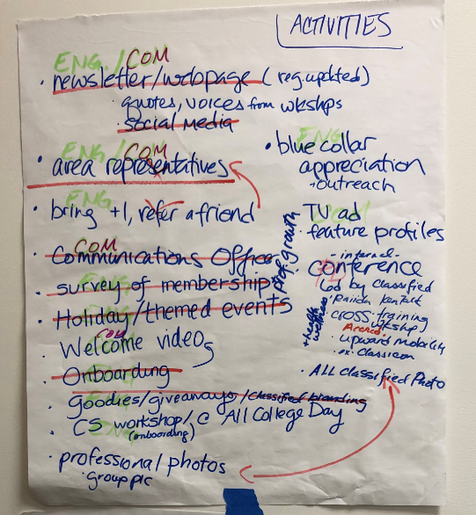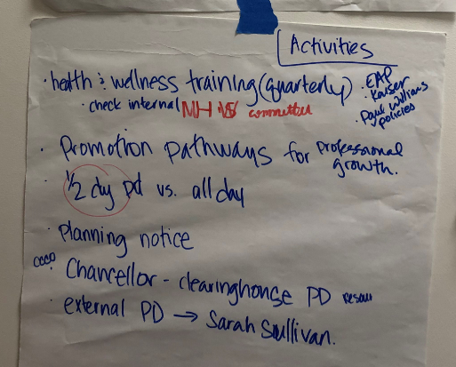
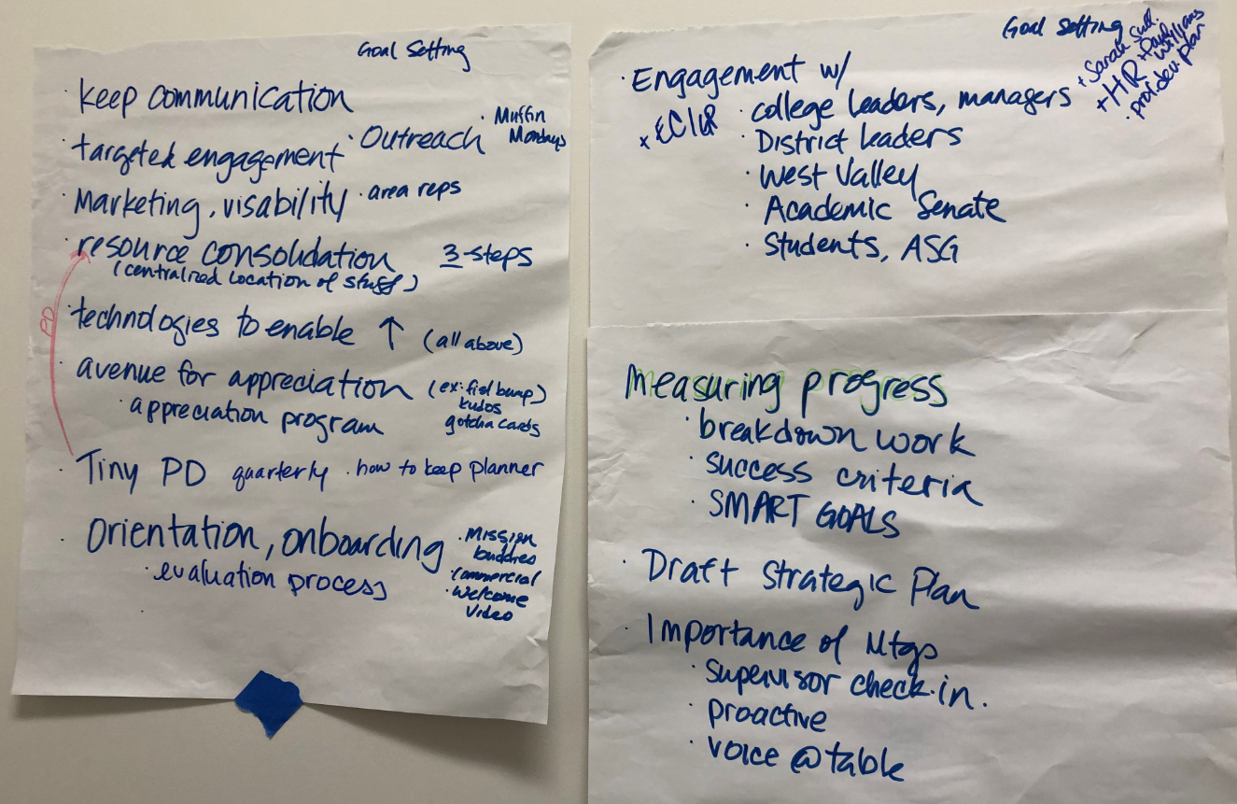

Voting Results of Priorities:
COMMUNICATION TEAM
Lead: KRISTAL
- Newsletter (11) - need establish committee
- Communications Officer (10): Proposal for development: Tracey Ward
- Surveys (7)
- Emails (4)
- SharePoint (2) - not prioritized but can be maintained/updated
- Social Media (1)
- Webpage (0) - not prioritized but can be maintained/updated

ENGAGEMENT TEAM
Lead: THANH
- Area Reps (11) - Next page draft
- Orientation & Onboarding (9)
- Appreciation Program (9)
- Events (except PD) (7)
- Crazy Hat Day (October) - October 17th - Wear a crazy hat
- Transfer Day (October) - October 14th - Wear your alma mater/fave university/college
- Holiday theme events – TBD
- Elections (Feb-March) - Need committee established in January
- Awards Ceremony (Apr-May) - Need Awards/Nominations committee established by March
- Goodies & Giveaways (3)
PROFESSIONAL DEVELOPMENT TEAM
Lead: DAT
- Tiny PD (13)
- Conference utilizing our CS staff (9)
- Health & Wellness Trainings (5)
- Work with HR – utilize Danielle Ramirez-King
- PD Day (4) - January - not prioritized but will still occur for the year
- Promotional Pathways (3)
- All College Day Workshop (2)

Conclusion

Summary of Goals
Goals:
- Increase and improve communication
- Establishing a communications officer
- Creating and distributing a monthly/quarterly newsletter
- Continue use of surveys for feedback and input from staff
- Increase and improve engagement
- Establish area representatives utilizing Senators
- Establish orientation and onboarding for Classified Professionals
- Establish Classified Appreciation Program
- Increase and improve professional development activities
- Establish “Tiny PD” days
- Plan Classified Professionals conference using MC Staff
- Coordinate trainings with District HR

Action:
- Communicate outcomes from retreat.
- Communicate next steps from retreat until next meeting, Thursday, September 19
- Draft Strategic Plan
- Start high-level planning, scheduling, feasibility for priorities identified in retreat.
- Share Draft Strategic Plan for all senate input to share results at September meeting
- Develop Process to measure progress
- Communicate importance of meetings
- Dat to send out information on Lynda.com
- Research 9+1 policy process for faculty and students to prepare for a 9+1 Action Plan.

Questions:
- How do we align our senate charge to 9+1?
  - Draft Response: Review Mission Statement activity from Classified Professionals in OnCourse training here, develop final Mission Statement for Classified Senate. Integrate work into Strategic Plan.
- How do we activate 9+1?
  - Draft Response: Develop a plan.
- What is our communication with supervisors, support levels – how do we make it clear that supervisors support staff in participatory governance, how do we close gap?
  - This is an ongoing discussion with President Peck.
- Are we meeting with administrators?
  - Classified Senate President has been meeting 1-1 with President Peck, new meetings will include Guided Pathway Chairs and Academic Senate President, and a new proposal for a Presidents meeting to discuss general college business.
- Have we gone to Academic Senate?
  - The meetings are open to all, and we will do a call-out for interested Classified Professionals to regularly attend Academic Senate meetings. These meetings occur every Thursday from 2-4 and usually conflict with Classified Senate monthly meetings.
- Is there an orientation for new staff?
  - This is a prioritized proposed activity for Classified Senate.
- Proposal to include language on institutional responsibilities in union contracts, and response from the District is – who is not participating.
  - CEA Representative (Lori) response, shared that a common question from District – Who’s not participating?

Additional suggestions:
  - For future or at least 2019-2020 meeting, SWOT analysis of the year and our goals/tasks. “Final Review of the Year”

Retreat Feedback:
- Great productive meeting.
- Inspiring input from all attendees. Attendees appeared comfortable with providing suggestions.
- Refreshing input.
- Cell phones were still an issue.
- Great facilitator.
- Wonderful space.

Retreat Materials
On SharePoint
- PowerPoint Presentation
- Agenda
- 9+1 Document
- Bylaws
- Photos

Updates - Follow Up: 2019-2020 High-Level Planning Initiated

Strategic Planning Document
https://wvmccd.sharepoint.com/:w:/s/MissionCollegeClassifiedSenate/EXpSNT3QNq9LpAp8X5Uk0GoB4VENHR1Su2CV8hnndC9SZA?e=mWxhru (editable)

Classified Senate Mission Statement Drafts
(Using On Course efforts from June 21st see drafted Mission Statements below)
https://tasks.office.com/wvm.edu/en-US/Home/Task/0Bh8bSHeD0aUr6YfvojrcmQAOmfW?Type=TaskLink&Channel=Link&CreatedTime=637009742751424043

Drafted Mission Statements:
Group #1: (9 votes)
Using a student-centered approach, empower students to become successful life-long learners, proactively engage, empathize, and provide students
- Resources
- Knowledge
- Tools
- Guidance
#Don’tAssume #WeAreMission
Group #2: (11 votes)
Through a lens of equity and empathy, to empower students toward success by providing tools, resources, information and guidance.
- Open-minded
- Active Listening
- Equity
- Peace
Group #3: (1 vote)
To Provide Guidance to college students through friendly & efficient customer service.
Group #4: (2 votes)
Welcoming Environment “Come as One, Leave as Family” We commit to ensure student success, retention & broad range of networks.
Group #5: (9 votes)
Identify Student’s Need. Provide information that will support resolution of their current issue and ultimately support their long-term educational goals.
Group #6: (12 votes)
To provide a welcoming environment to our community by providing:
- Courteous Services
- Being a good listener
- Bring compassionate, empathetic, understanding
- Helpful resources
- Respect without judgement
To ensure the success of our students to meet their educational goals.
Group #7: (2 votes)
With a committed holistic approach to educate students’ mind, body, and soul, our staff and faculty are committed on providing a safe, inclusive and welcoming environment.
Group #8: (16 votes)
To provide courteous service to our diverse population, so they are able to focus on acquiring knowledge and skills as well as lifelong learning.
To provide a meaningful education in a multicultural diverse environment.
To serve as a source of information to help students navigate their career path with guidance and support.

Engagement: Area Representatives Senators [Confirmations Needed]
Purpose: To ensure distribution, Senators were either assigned by functional area and/or office location/proximity to other areas/departments

Next steps: Thanh to check in with each senator on area representation.

Action: Need to establish expectations and templates(s) of communication.
- Introduction – If a Senator is unfamiliar or new to assigned areas, encourage to engage and introduce yourself to your areas staff.
- Point of Contact – you are a liaison, a buddy, a resource, an “encourager”, an “engager” 😊

Senator/Area Rep | Area/Departments | Staff
Amanda Marshall | Academic Support, Center, CalWorks, EOPS/TRiO, Counseling/Transfer Center | Jeff B., Willette, Amanda, Vianey, Linda, Mary Ann
Analiza Dasalla | Athletics. Community Education, Marketing | Analiza, Mark, Ken, Shelbie, Saul, Spencer
Jeff Campi  Thanh | Facilities: Custodial (Day), Grounds,  Building Maintenance, HVAC, Plumber | Gary, Maria, Pablos, Edward, Lloyd, Rafael, Thu, Daniel M., Ricky, Abel, Jeff
Kelvin Tran | Financial Aid, Research, Student Equity | Cherry, Eleen, Ha, Marie, Ngoclien, Rene, Roehl, Alison, Erik, Thanh, Kelvin
Kendall Harrison | Career Technical Education, Hospitality Management | Kendall, Lori, Marie, Sandy
Lisa Willet | Admissions & Records | Anthony, Asmare, Diemanh, Elvita, Jhonaliza, Lisa, Melissa, Nitha, Phyllis
Lusyna Narvaez  (Back up – Kendall) | Child Development Center | Delia, Karina, Kerry, Lan, Lisa C., Lisa M, Nang, Nguyet, Phuong, Shuchi, Tricia, Vandana, Yareli, Thien
Mario Flores | HSI-STEM, AANAPISI, Science Building | Mario, Lusyna, Raiida, Julian, Emilio, Barbara, Jennifer Y., Uma, Polina
Melissa Stewart | Office of Instruction, Instructional Offices, Academic Senate | Melissa, John, Genina, Linping,  Tina, Kena, Thuy, Beverly, Mark, Lisa S., Liz, Chris W.
Monica Sain | Office of Admin Services, Office of Advancement, Adult Education, HWI | Monica, Joanne, Anita, Kristal, Chris, Brian, Queenie, Danielle
Nini Reyes-Bolinger | Facilities - Custodial (Swing/Night)  District Warehouse & Facilities | Nini, Randy, Nathan, Aaron, Bruce, Hai, Jorge, Luvinio, Miu Ping, Raymond, Reynaldo, Roberto, Fidelina, Jose
Renee Ruzicka | Educational Technology Services, Information Systems, Library | Renee, Denise, Nahid, Luis, Allan, Dat, Greg, Ryan, Patrick, Robert
Tracey Ward | Internationals Students Center, Job & Internship Center, Welcome Center | Tracey, Jouney, Star, Andrew, Julie
Vianey Topete | Outreach, Student Health Services | Connor, Katy, Lucia, Bebe, Charlene, Barbara
Zita Melton | DSPS, Parking Services, Student Activities, Student Services, Valor Center | Zita, My, Liz, Gladys, Marianna, Nan, Xuan, Lydia, Thuy Pham, Christina

